# **How to Create Menu Locations**

## **What is the menu Locations?**

Menu Position will allow admin to set any page for the user to navigate the website from the front end website.

## **Why do we need to set the Menu Locations?**

By default wordpress different theme provide the different menu position like twentytwenty provide the following menu position

1. Primary - Desktop Horizontal Menu
2. Expanded - Desktop Expanded Menu
3. Mobile - Mobile Menu
4. Footer - Footer Menu
5. Social - Social Menu

Why do we need

* Menu Position is where your menu will visible to the front end website to the user
* If you want to browse a specific page only then you can set that page in the menu and it will display in a given position to the user.

## **How to Create your own Menu Locations?**

1. Open functions.php and find this twentytwenty_menus()
2. Add your Menu name in that function

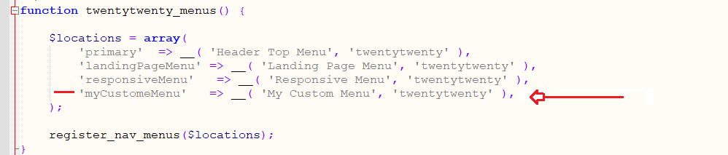

'myCustomeMenu' => __( 'My Custom Menu', 'twentytwenty' ),

1. You can see your custom menu in backend Appearance >> Menus >> Manage Locations

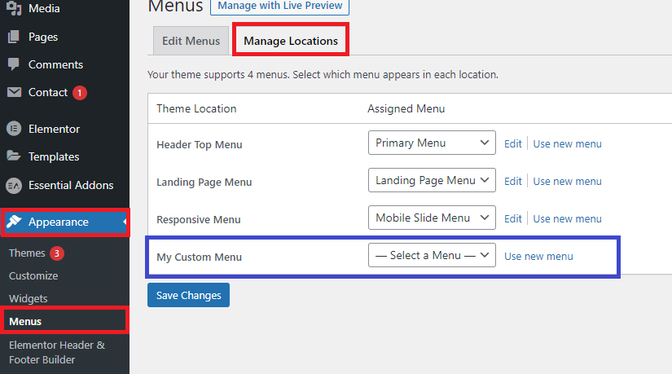

1. Now Create a menu in back-end and serve to this location

## **How to Create a Menu in the Back-end for custom locations?**

1. Appearance >> Menus >> Click on create menu link

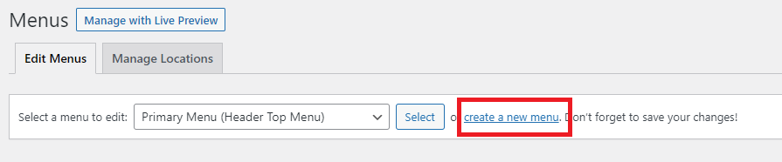

1. Enter Menu Name and Select the custom location and click on Create Menu button

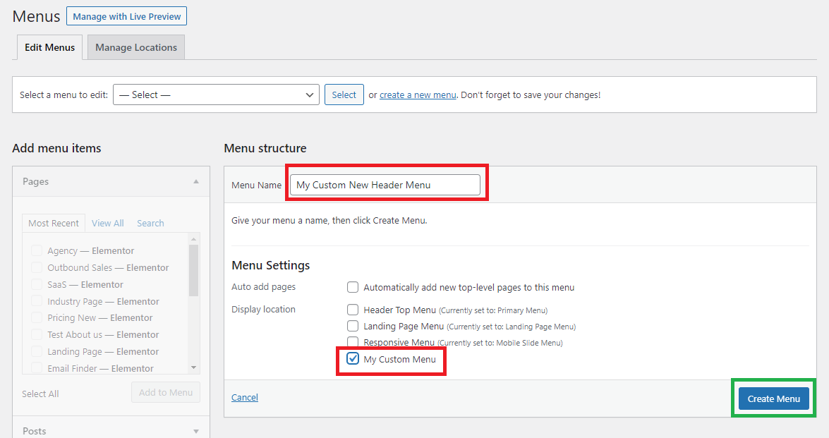

1. Greate You menu is created now

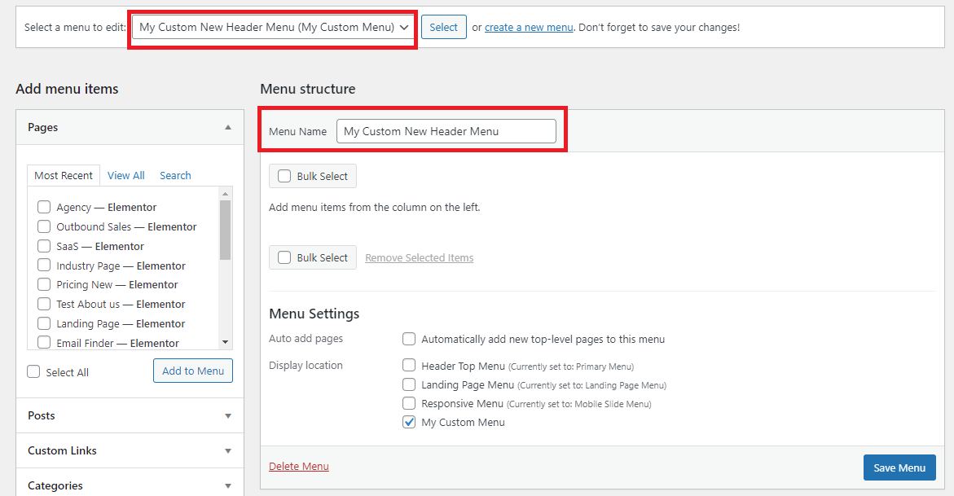

Select the Pages from the left section **“Pages”** and click on Add to menu button

Then click on “**Save Menu”** Button

Your custom menu is set for the custom location.

## **How to Set Custom menu display on front end website?**

Go to the file where you want display that custom menu for the front end user in this

demo we are going to display in header so we have open header.php

Add below code which display your custom menu

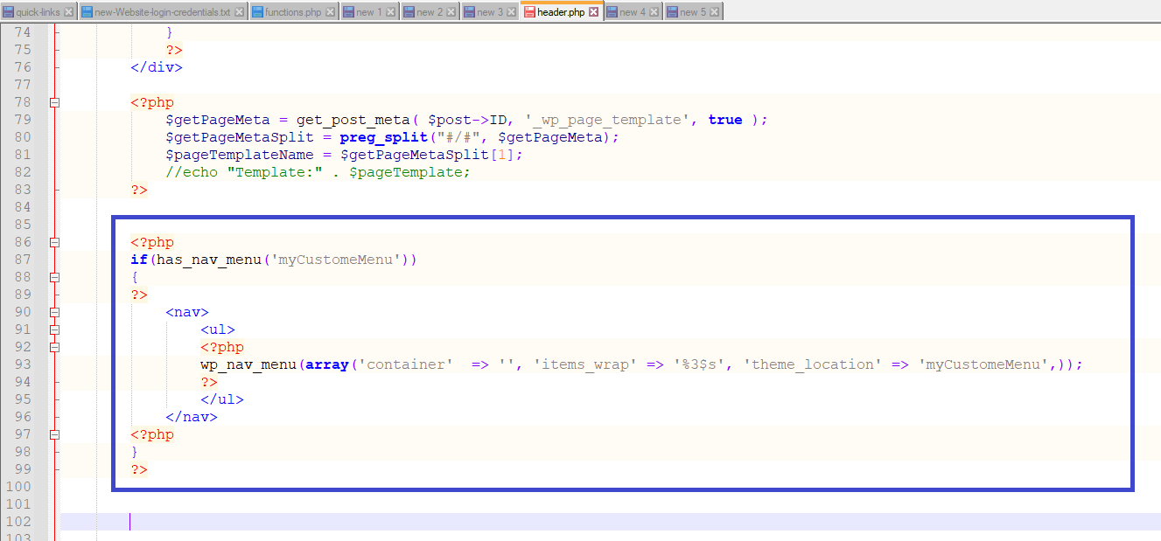

<?php

if(has_nav_menu('myCustomeMenu'))

{

?>

<nav>

<ul>

<?php

wp_nav_menu(array('container' => '', 'items_wrap' => '%3$s', 'theme_location' => 'myCustomeMenu',));

?>

</ul>

</nav>

<?php

}

?>

myCustomeMenu :: is the id which we set in function.php

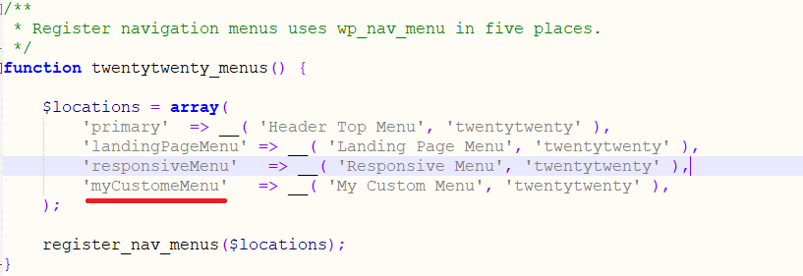

**Awesome you have set your custom menu run on the browser and check**

